Main Commands
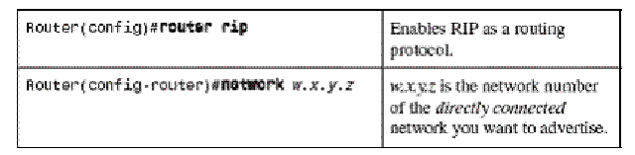
Explanation:
Lets apply RIP protocol on the following topology.
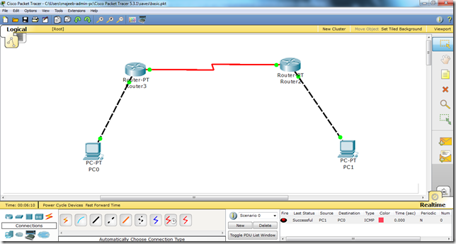
Now, we will follow the steps as mentioned in detail in the following article. i.e.
i. We will assign IP addresses to all the fast Ethernet and serial interfaces respectively.
ii We will change the state of the interfaces from down to UP.
Then, after we are done with the basic step. We will apply RIP protocol commands on both routers.
As follows.
R1
In order to apply protocol RIP, we will write the following set of commands.
Router(config)# router rip
Router(config-router)# network 192.168.1.0
Router(config-router)# network 192.168.2.0
Router(config-router)#exit

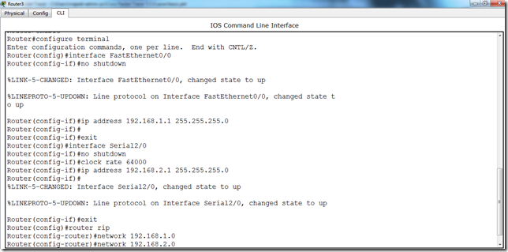
R2:
In order to apply protocol RIP, we will write the following set of commands on R2 as well.
Router(config)# router rip
Router(config-router)# network 192.168.1.0
Router(config-router)# network 192.168.2.0
Router(config-router)#exit
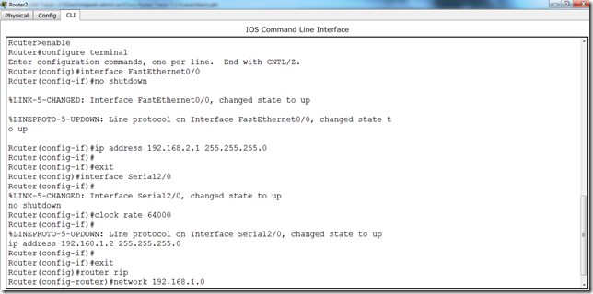
Write all the commands in the same fashion as in the above screen shots and voila, we are done with RIP protocol. Another important thing here is that we will add all the networks that we are using in our topology. Here in this particular example i am just using two networks x.x.1.0 and x.x.2.0 so thats why i have added these two network addresses to the RIP protocol.
Now, you can check it. Traffic is enabled and you can easily send data from PC0 to PC1.

Commands:
Step 1:
Pc-0
IP: 192.168.1.2
G/W: 192.168.1.1

Pc-1
IP: 192.168.3.2
G/W: 192.168.3.1

Router0:
CLI:
-no
-en
-conf t
-int fa0/0
-ip address 192.168.1.1 255.255.255.0
-no shut
-int s0/0/0
-clock rate 64000
-ip address 192.168.2.1 255.255.255.0
-no shut

Router1:
CLI:
-no
-en
-conf t
-int s0/0/0
-ip address 192.168.2.2 255.255.255.0
-no shut
-int fa0/0
-ip address 192.168.3.1 255.255.255.0
-no shut

Step 2:
Try to ping from pc0 to pc1
Failed.

Step3:
router0
-exit
-router rip
-network 192.168.1.0
-network 192.168.2.0

router1
-exit
-router rip
-network 192.168.2.0
-network 192.168.3.0

